User ID Controlled by Request Parameter – Data Leakage in Redirect
Platform: PortSwigger Web Security Academy
Lab Level: Apprentice
Lab Name: User ID controlled by request parameter with data leakage in redirect
Category: Access Control / Information Disclosure
Author: Chamika Jayasooriya
Field: Cybersecurity / Penetration Testing
Date:

1. Introduction
This document provides a professional security lab write-up for the “User ID controlled by request parameter with data leakage in redirect” lab from the PortSwigger Web Security Academy. The lab demonstrates how sensitive information can be exposed when an application leaks data within the body of an HTTP redirect (302) response.
Although the application performs a redirect to another page, sensitive data such as API keys are still included in the response body, allowing attackers to retrieve confidential information by inspecting HTTP traffic.

2. Lab Objective
The objectives of this lab are:
- Log in as a normal user
- Observe application behavior during redirects
- Identify sensitive information leaked in a redirect response
- Extract and submit another user’s API key

3. Vulnerability Overview

3.1 Vulnerability Type
- Broken Access Control
- Information Disclosure
- Sensitive Data Exposure via Redirect

3.2 Description
The application uses user IDs in request parameters to identify accounts. When an unauthorized request is made, the server issues a 302 redirect to the login page. However, the response body still contains sensitive information (API key) before the redirect occurs, resulting in unintended data exposure.

4. Tools & Environment
- Web Browser (Chrome / Firefox)
- Burp Suite (Proxy & HTTP History)
- PortSwigger Web Security Academy Lab Environment

5. Test Accounts Used
Username | Password | Role
wiener | peter | Normal User
carlos | Unknown | Normal User

6. Step-by-Step Exploitation

Step 1: Log in as Normal User
Log in using the provided credentials:
- Username: wiener
- Password: peter
Navigate to the My Account page.
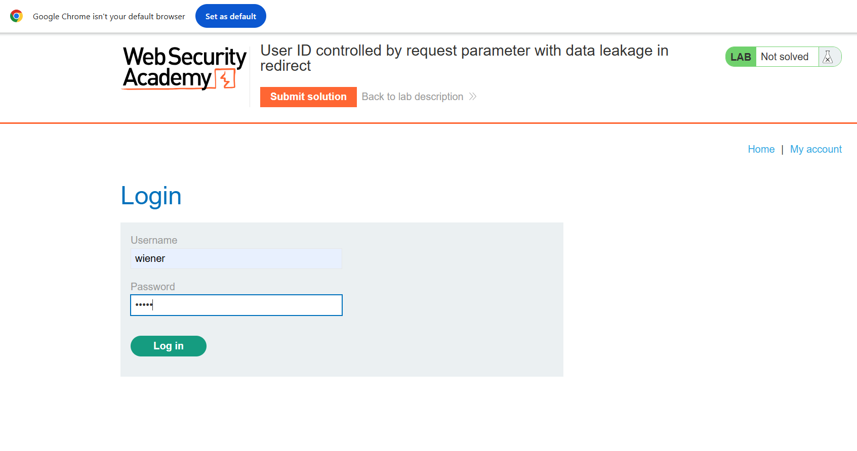

Step 2: Observe Unexpected Redirect Behavior
While accessing the account page, the application redirects the user to the login page despite already being authenticated.
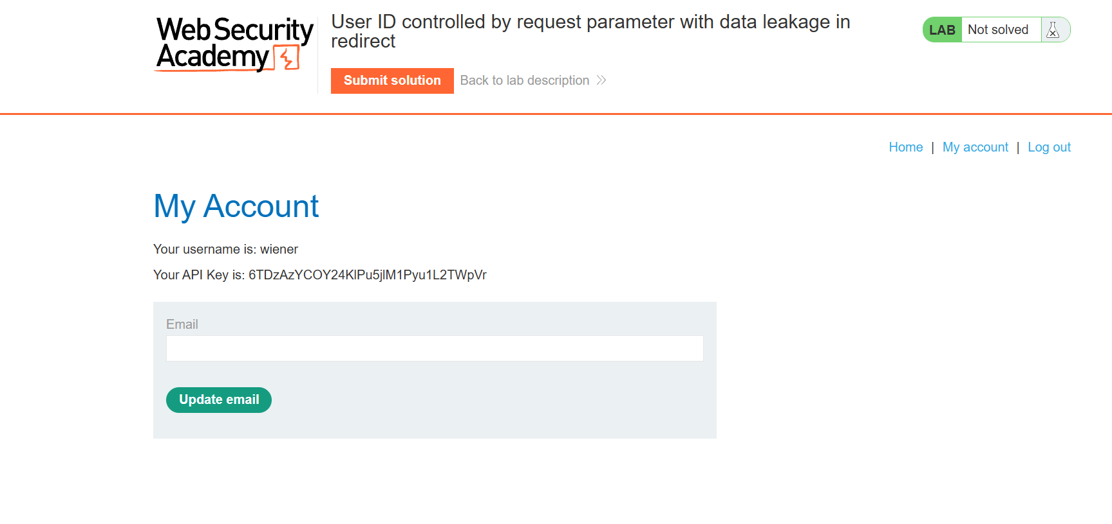

Step 3: Intercept the Redirect Response
Using Burp Suite, inspect the HTTP history and locate a GET request returning a 302 status code related to the account page.
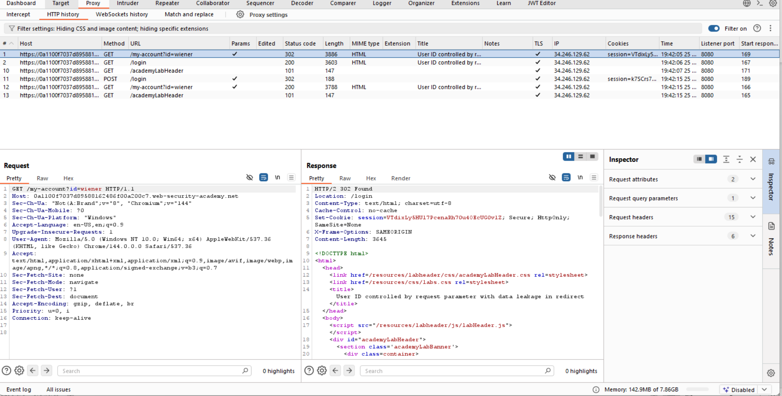

Step 4: Identify Data Leakage in Response Body
Examine the body of the 302 redirect response. Despite the redirect, the response body contains sensitive data, including the API key.
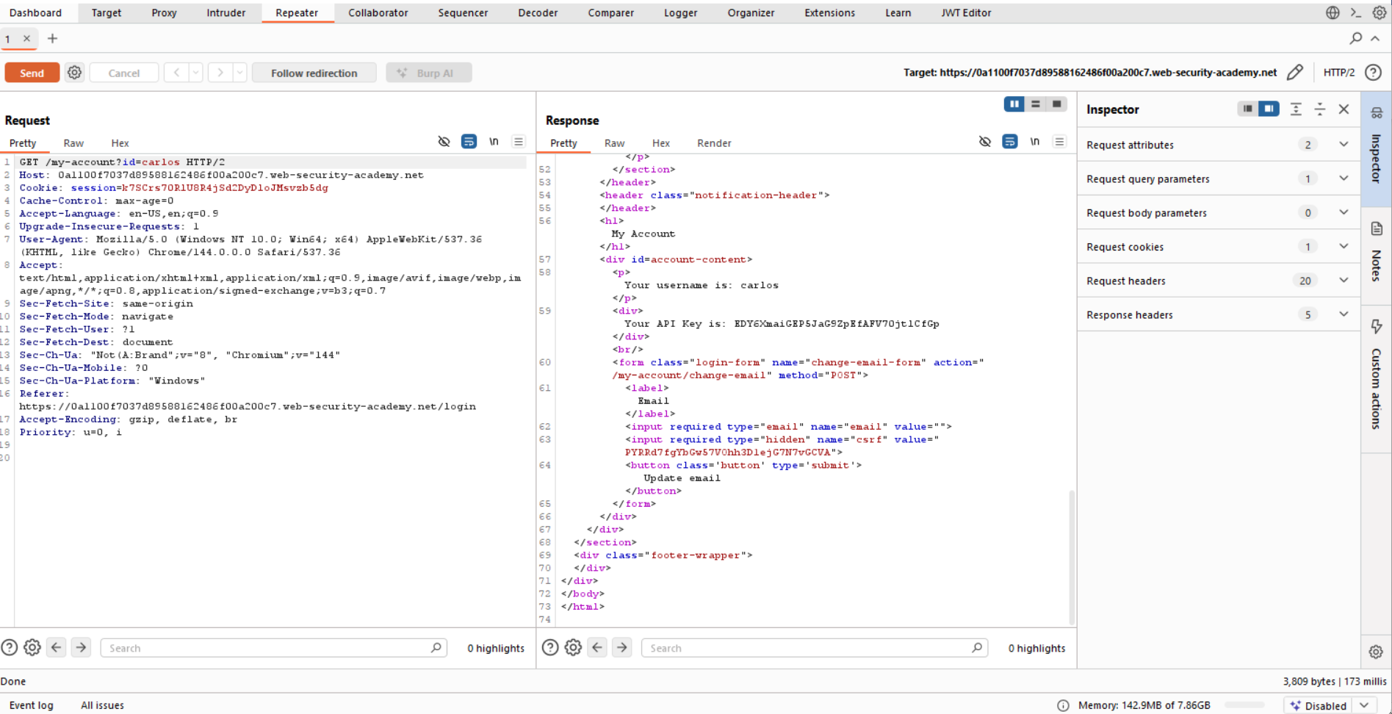

Step 5: Extract and Submit the API Key
Copy the exposed API key from the response body and submit it as the lab solution.
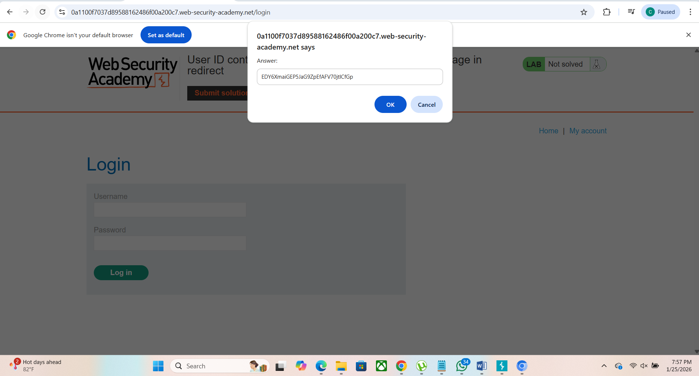

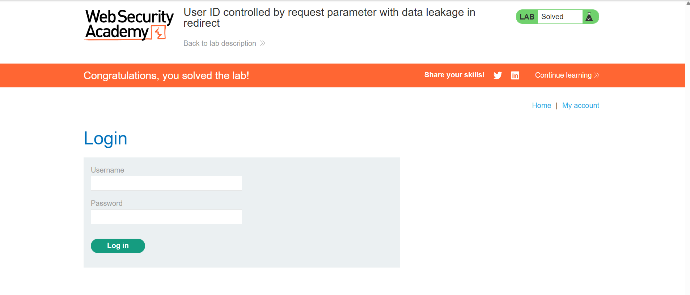

7. Impact Analysis
- Exposure of sensitive user information
- Unauthorized access to API keys
- Potential abuse of backend APIs

8. Root Cause
The server generates sensitive content before issuing the redirect and fails to suppress the response body. As a result, confidential data is transmitted even when access should be denied.

9. Mitigation & Recommendations
- Never include sensitive data in redirect responses
- Ensure redirect responses contain empty or minimal bodies
- Enforce strict server-side access control before data generation
- Validate authorization prior to processing user-specific requests

10. Conclusion
This lab demonstrates that redirects do not automatically prevent data leakage. Security controls must ensure that sensitive information is never included in HTTP responses unless the user is fully authorized.

11. References
- PortSwigger Web Security Academy – Access Control Labs
- OWASP Top 10 – Broken Access Control
- OWASP – Sensitive Data Exposure

12. Author
- Name: Chamika Jayasooriya
- Field: Cybersecurity / Penetration Testing

